Intro to Java
CSL215
Project Report


Department of Computer Science and Engineering
The NorthCap University, Gurugram- 122017, India
Session 2025-26

Faculty : Mrs. Swati Gupta

Library Management System
Team Members:
- Member 1 : SIA GUPTA (24CSU201)
- Member 2 : AADITIYA CHAUHAN (24CSU362)
- Member 3 : JIYA GOSAIN(24CSU313)

1. Objective and Problem Statement
This application acts as a complete digital registrar for a small library. It enables administrators to manage book inventory, maintain member accounts, and track issue/return transactions in real time. All data is stored using persistent file handling, ensuring records remain safe even after the system is closed. The system validates availability, prevents invalid transactions, and keeps a clear history of all activities for easy auditing. With a simple and organized structure, it provides a reliable and efficient solution for day-to-day library operations without requiring any external database.

2. Features and Functionalities
Fully Interactive Menu System
- Main menu for Books, Members, Transactions, Exit
- Submenus for Add, View, Issue, Return
Persistent Data Storage
- Books and Members stored in .txt files
- Loads automatically at startup and saves on exit
OOP Concepts
- Encapsulation: Private fields + getters/setters
- Inheritance: Person → Member/Librarian
- Polymorphism: read/write function is overridden
- Array of Objects: Library stores all books & members in arrays

Exception Handling
- Invalid inputs
- Missing files
- Number parsing issues
- Transactions and validation checks
Transaction System
- Issue book
- Return book
- Check availability
- Member validity

3. Design and Class Diagram
Library_Management_Project
│
├── library (main project package)
│ │
│ ├── main.java (main class / executable)
│ │
│ ├── models (package)
│ │ ├── Person.java (class - parent model)
│ │ ├── Member.java (class - model)
│ │ ├── Book.java (class - model)
│ │ ├── Librarian.java (class - model)
│ │ └── Transaction.java (class - model)
│ │
│ ├── filehandling (package - file handling)
│ │ ├── FileHandler.java (class - base file handler)
│ │ ├── MembersFH.java (class - file handler functions)
│ │ ├── BooksFH.java (class - file handler functions)
│ │ ├── TransactionsFH.java (class - file handler functions)
│ │ └── WishlistFH.java (class - file handler functions)
│ │
│ └── services (package - service layer)
│ ├── LibraryService.java (class - general services)
│ ├── LibrarianService.java (class - librarian functions)
│ └── MemberService.java (class - member functions)
│
├── books.txt (data file - books database)
├── members.txt (data file - members database)
├── transactions.txt (data file - transaction logs)
└── wishlist.txt (data file - wishlist storage)
4. Code Explanation (Key Snippets)

P1 — System Interface (Menu / Loops)

Requirement: Must have text-based main menu + sub-menus with continuous loops.
Snippet:
while (true) {
System.out.println("1. Add Book");
System.out.println("2. Add Member");
System.out.println("3. Issue Book");
System.out.println("4. Return Book");
System.out.println("5. Transactions");
System.out.println("6. Search Book");
System.out.println("0. Exit");
choice = sc.nextInt();
}

P2 — Data Persistence (File I/O)

Requirement: File Handling using .txt or .csv.
Snippet :
BufferedReader br = new BufferedReader(new FileReader("Books.txt"));
String line;
while ((line = br.readLine()) != null) {
// reading stored books
}
br.close();
BufferedWriter bw = new BufferedWriter(new FileWriter("Books.txt", true));
bw.write(bookID + "," + title + "," + author + "," + genre);
bw.newLine();
bw.close();

P3 — Error Handling
Requirement: Must use try–catch for File I/O + input validation.
Snippet :
try {
BufferedReader br = new BufferedReader(new FileReader("Members.txt"));
} catch (IOException e) {
System.out.println("Error loading members file.");
}
try {
int choice = Integer.parseInt(sc.nextLine());
} catch (NumberFormatException e) {
System.out.println("Invalid number! Try again.");
}

P4 — OOP: Encapsulation
Snippet:
private String bookID;
private String title;

public String getTitle() { return title; }
public void setTitle(String t) { this.title = t; }

P5 — OOP: Inheritance
Snippet:
public class Person {
private String name;
private String email;
}

public class Member extends Person {
private String memberID;
}

public class Librarian extends Person {
private String employeeID;
}

P6: POLYMORPHISM
SNIPPET:
Interface
package library.services;

public interface LibraryService {
void issueBook(String memberId, String bookId);
void returnBook(String memberId, String bookId);
void searchBook(String keyword);
void viewTransactions(String memberId);
}

P7 – ARRAY OF OBJECTS
Snippet :
This snippet is taken directly from your viewAllBooks() method.
Book[] b = new Book[books.length]; // Array of Book objects

for (int i = 0; i < books.length; i++) {
String[] p = books[i].split(",");
if (p.length >= 4) {
b[i] = new Book(p[0], p[1], p[2], p[3]); // Storing Book objects into array
}
}

P8 – OBJECTS AS ARGUMENTS

Snippet:
issueBook()
public void issueBook(Book book, Member member) {
if (book.isAvailable()) {
book.setAvailable(false);
System.out.println("Book issued to: " + member.getName());
} else {
System.out.println("Book is currently unavailable.");
}
}

P9 — Logic Control (Conditionals)
Snippet ::
if (book.isAvailable()) {
issueBook(memberID, bookID);
} else {
System.out.println("Book not available.");
}
switch(choice) {
case 1: addBook(); break;
case 2: addMember(); break;
...
}
P10 — Structure (Packages)
Snippet:
package library.models;
package library.filehandling;
package library.services;
package library.main;
6. Sample Input & Output Screens

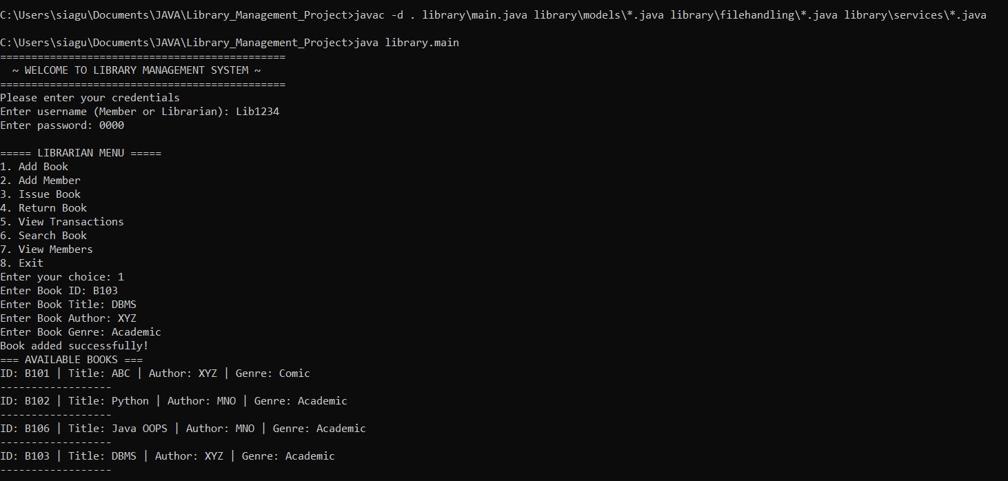
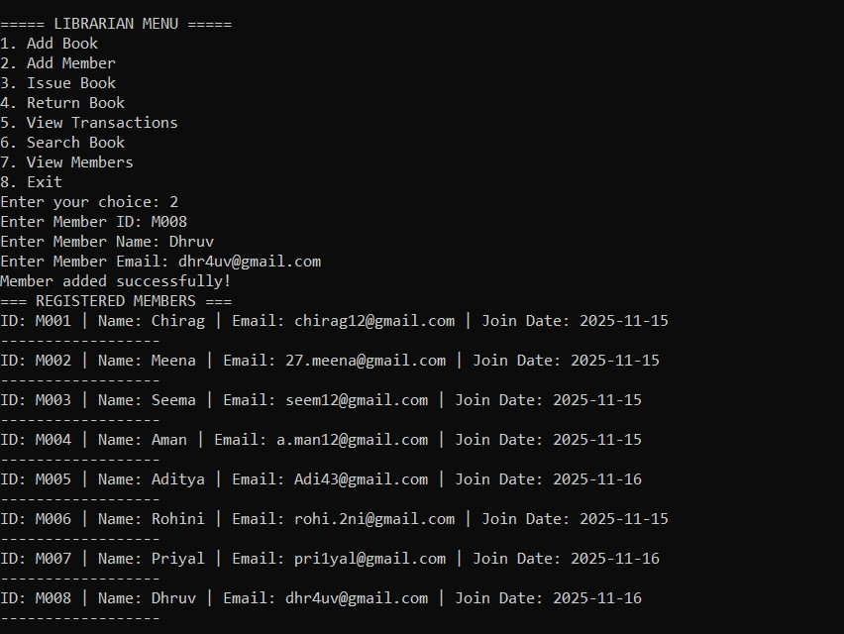
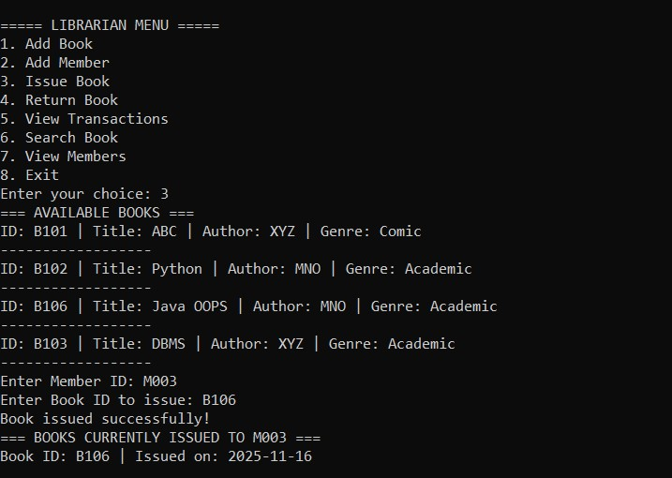
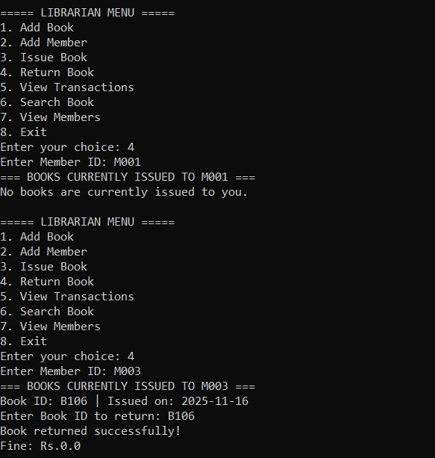
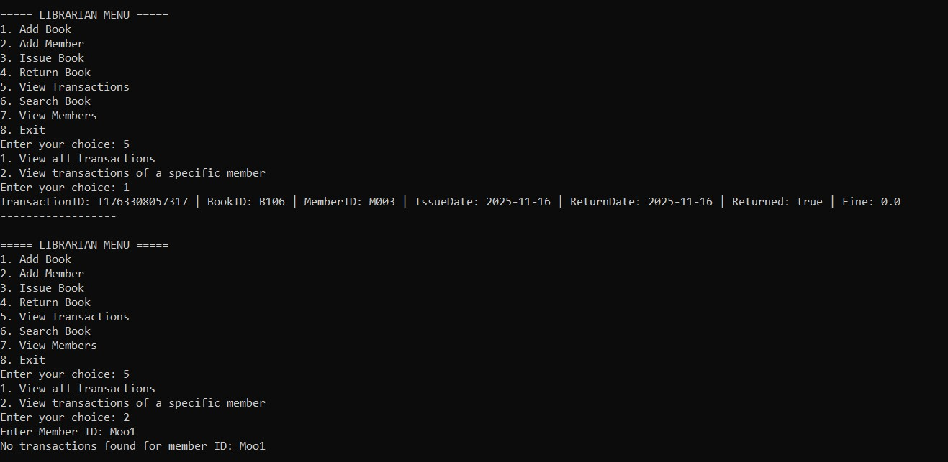

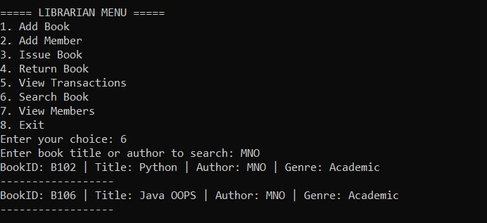
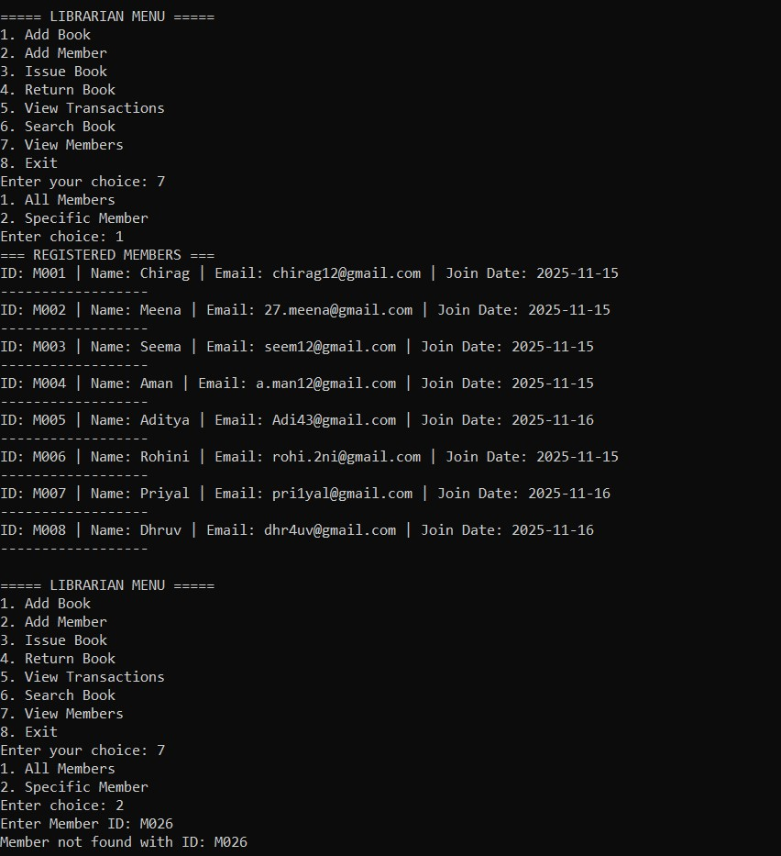
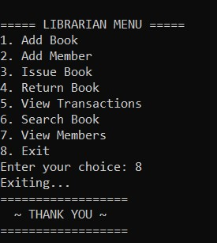

Conclusion and Future Scope
The Library Management System successfully meets all academic requirements (P1–P10). It demonstrates Java OOP concepts, File I/O persistence, a structured package system, menu-driven interaction, and complete transaction management.
Future Enhancements
- GUI (JavaFX / Swing)
- Database integration (MySQL)
- Fine calculation automation
- OTP-based login

References
- Oracle Java Documentation
- Java: The Complete Reference
- GeeksforGeeks Java I/O Tutorials
- Official Collections Framework Guide

PROJECT DISTRIBUTION
Name | Roll No. | Responsibility
Member 1 | 24CSU201 | Services (all service classes, logic handling, issue/return, menu flow)
Member 2 | 24CSU362 | File Handling + Main File (FileService, data storage, loading, main application)
Member 3 | 24CSU313 | Models (Person, Member, Book, all model classes and OOP structure)

